Online Interactive Activity Pack

Future Cities Challenge

Background:
Over the next two decades, transport technology will change faster than at any time since the Victorian era. We will see autonomous vehicles driving on the roads and flying drones will be delivering goods to people’s houses micro transport, perhaps even jet packs will become a regular sight. The advent of new technologies is already revolutionising the ways in which we think about travel and more than ever today, transport can help to create green, safe, healthy, connected, and inclusive communities.

The students of today will be living in tomorrow’s Cities of the Future. This Interactive Activity Pack is designed to encourage students of various ages to think creatively about solving real-world problems and making our transport networks safer, while encouraging them to get into Transport Planning and the wider sector. Task organisers such as STEM Ambassadors can use this Interactive Activity Pack to encourage and support more students to imagine their very own ‘City of the Future’.

Requirements:
Each student should have an opportunity to draw and display their ideas to the task organiser. Students involved in this activity will require access to a computer with a camera, pens, pencils, and paper. This exercise will work best if the task organiser / STEM Ambassador can send this information to all participants a few days before the event.

Future Cities Infrastructure Challenge:
Students are asked to imagine their own safe mode of transport and/or transportation system(s) that will support the infrastructure of the Cities of the Future.

How the Pack Works
- Students identify and write down which of the below problems they are going to solve and how much safer they can make them (a key concern for younger children).
- Students draw a sketch of what their ‘City of the Future’ looks like, including designs or sketches of new modes of transport (such as a solar powered car).
- Students write down how their own safe mode of transport and/or transportation system(s) work within their future city to solve the below problems.

Optional Tasks for Students:
- Draw/sketch a future invention, explain what it is, what it does and what problems it solves.
- Consider opportunities to develop and support your ideas (e.g., a marketing campaign to support their inventions.
Problems to Solve:
Students look at the series of questions below and consider how their mode of transport and/or transportation system(s) will solve these at least two of these problems.

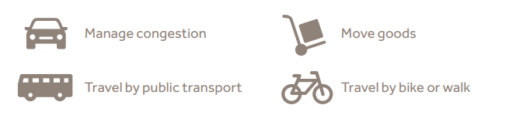

- Manage Congestion
How can roads be made less busy? The population is increasing every day, towns and cities have more people living in them than ever before. Traffic congestion causes delays, frustration, and pollution.

- Your task is to suggest / draw or sketch ideas of how the roads can be made less busy

- Moving Goods
How would this future city help to make moving goods easier? Goods, such as food and materials need to be moved around the country to where they will be used or sold. Goods are currently moved by vehicles, including aeroplanes, rail, motorcycle, vans, pedal cycles, lorries, boats and cars.

- Your task is to suggest / draw or sketch how this future city can help to make moving goods easier?

- Travel by Public Transport
How do we get more people using public transport? The population is increasing every day. How do we get more people using public transport, such as buses, trams, and light rail?

- Your task is to suggest / draw or sketch ideas to show how your future city will get more people using public transport.

- Travel by Bike or Walk - Personal Transport
How can we encourage people to cycle or walk for health and wellbeing benefits? Due to the Covid-19 crisis, more people than ever are using personal modes of transport, be that walking or cycling.

- Your task is suggesting ideas of how we get even more people use personal forms of transport. Are there future modes of personal transport you can imagine?

Optional Problems to Solve:

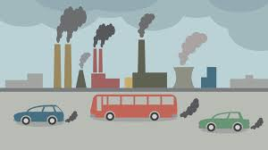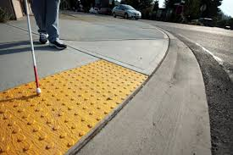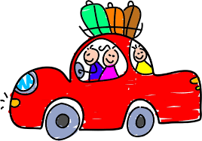

Pollution Accessible Mobility Making Journeys Fun

- Pollution
How will your mode of transport and/or transportation system(s) help reduce pollution? Some cars produce carbon dioxide which causes global warming or damage the environment. More people need to use transport that does not produce bad emissions.

- Your task is to think of then draw a transport solution that does not cause global warming or damage the environment.

- Making Journeys Fun
How might long journeys be made more fun? Long journeys may become more of a thing of the future, how do we make long journeys more fun?

- Your task is to think of then draw a transport solution that is very fun to use but does not cause global warming or damage the environment.

- Accessible Mobility
How do we ensure that all the citizens of this future city can use all of the services? Remembering that not everyone has full mobility, or the ability to see or hear, how can we ensure that our future city caters to the needs of everyone?

- Your task is to think of then draw a transport solution that caters to the needs of everyone.

Questions:
Once the sketches have been completed, the students answer the two questions below.

- What were the main hurdles you faced and how did you overcome them?
- Now you can see your design, if you could change one thing, what would it be?

Feedback Survey (post event)
- Did you enjoy the challenge?
- What could we do to make this more fun?
- Are there other challenges you would like to do?

